The Title of an APT2026 Presentation

A. Author¹, B. Author² and C. Author²

¹Department of XXXX, Organization, City, Postcode, Country
²Department of XXXX, Organization, Postcode, Country
Keywords: first, second, third, fourth, fifth.

Presenting author email: author@author-organization.com

Use this template for abstract preparation and submit your abstract in .pdf format to the Aerosol and Particle Technology (APT) 2026 Conference.
The abstract should be in double column (like this example) and ONE page long (any additional page will be automatically deleted). Use A4 page set-up and make all margins (top, bottom, left, right) 20 mm wide. Use 10 pt Calibri font (except for the title which should be in 12 pt bold and in sentence case). Centre the title, the authors’ names, the addresses, keywords, conference topics and contact email address. Please compose a title that clearly and succinctly describes the content of your work, in order to maximise its impact.
Start each paragraph, except the first, with an indent. Justify the body of the text both left and right. Do not use page numbers. Keywords and listing of associated topics are there to draw attention to your abstract, and to help the organisers allocate the abstract to the most appropriate reviewers and conference session.
Write your abstract using clear language, focusing on what is novel and its importance for the field of APT.
Figures can be in colour or in black and white. Ensure that Figures and Tables have a caption and that they are numbered consecutively.

Table 1. Some interesting data.
Factor | Theory) | Experiment
A | 0.001 | 0.001
B | 0.002 | 0.002

References should be made in the style (Single Author, 1961), Author-A and Author-B (1979) or as Author et al (1999). Examples of references are shown below. Leave a blank line above the list of references, and also above the acknowledgements.
Section headings can be used, if needed, as well as equations.

Abstract review
- Abstracts describing original results (not anticipated future outcomes!) will be reviewed by the Scientific Committee and those that are not deemed appropriate will be rejected.
- Accepted abstracts titles and author lists will be listed in the conference brochure and on the conference website and abstract texts will be provided to conference attendees.
- To achieve wide representation in the oral presentations, closely related papers on similar subjects from multimember groups should be submitted as posters and only one underlying/foundational paper for oral presentation.
The abstract should be submitted through the APT2026 website: https://www.apt2026.org .
For any inquiry you may contact the organizes through the APT2026 web site

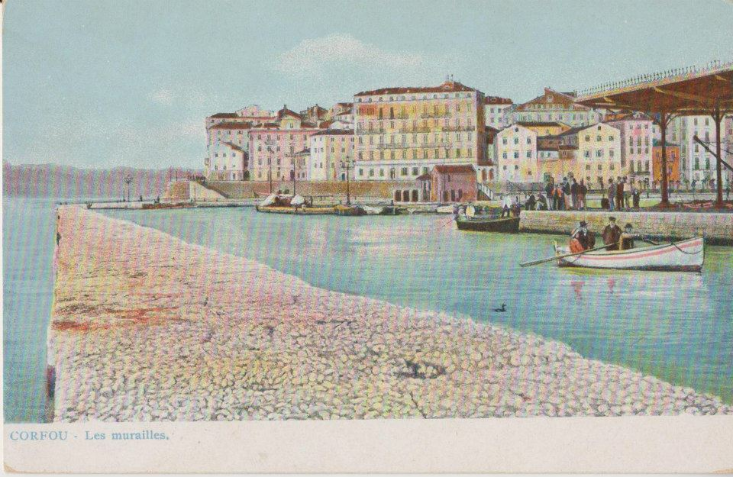

Figure 1. APT2026 at Corfu island, Greece

This work was supported by XXXXXXXXX under grant XXXX.

Paper_Author, A., Paper_Author, B. (Year) Journal Name. X, 145-150.
Proceedings_Author, C., Author, D. (Year). Proc. XXXX Conference, City, Country.
Book_Author. (Year) Book_Title, Publisher.

